**Influence of salinity on glycerol dialkyl glycerol tetraether**-**based indicators in Tibetan Plateau lakes: Implications for paleotemperature and paleosalinity reconstructions**

Qiangqiang Kou1,2, Liping Zhu1,2*, Jianting Ju1, Junbo Wang1, Teng Xu3, Cunlin Li1,2, Qingfeng Ma1

1 State Key Laboratory of Tibetan Plateau Earth System, Resources and Environment (TPESRE), Institute of Tibetan Plateau Research, Chinese Academy of Sciences, Beijing 100101, China

2 University of Chinese Academy of Sciences, Beijing 100049, China

3 Yellow River Institute of Eco-Environmental Research, YRBEEA, Zhengzhou 450004, China

* Corresponding author

E-mail address: lpzhu@itpcas.ac.cn (Liping Zhu)

**Supplementary Figures**

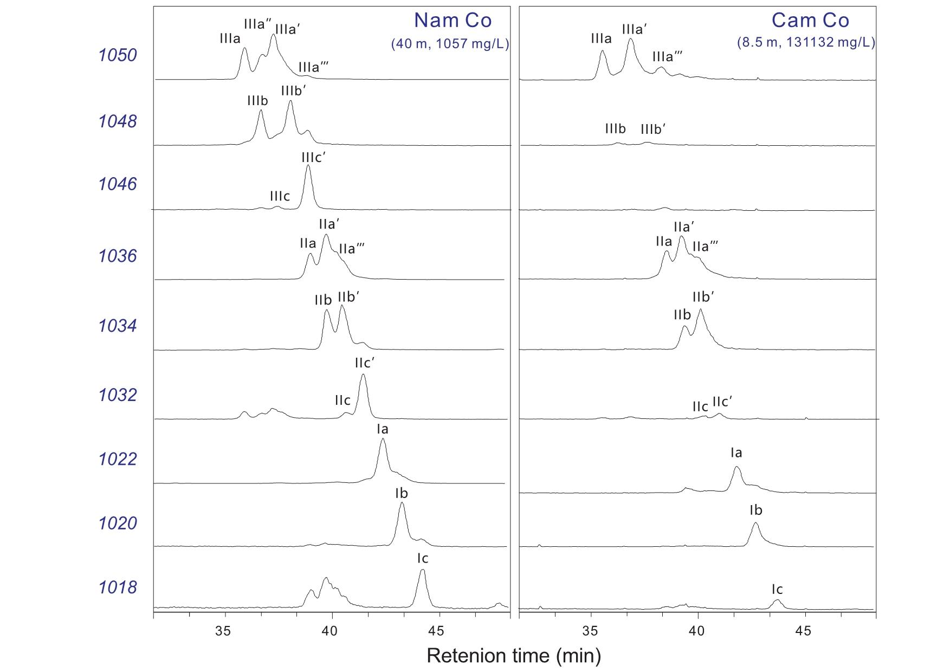

Fig. S1. Representative high-performance liquid chromatography/atmospheric pressure chemical ionization-mass spectrometry (HPLC/APCIMS) in TP lakes.

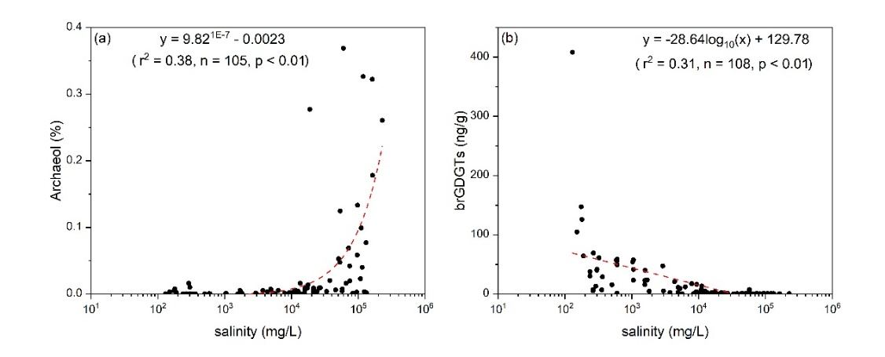

Fig. S2. Correlations of salinity with (a) relative amount of archaeol and (b) concentration of brGDGTs in TP lakes.

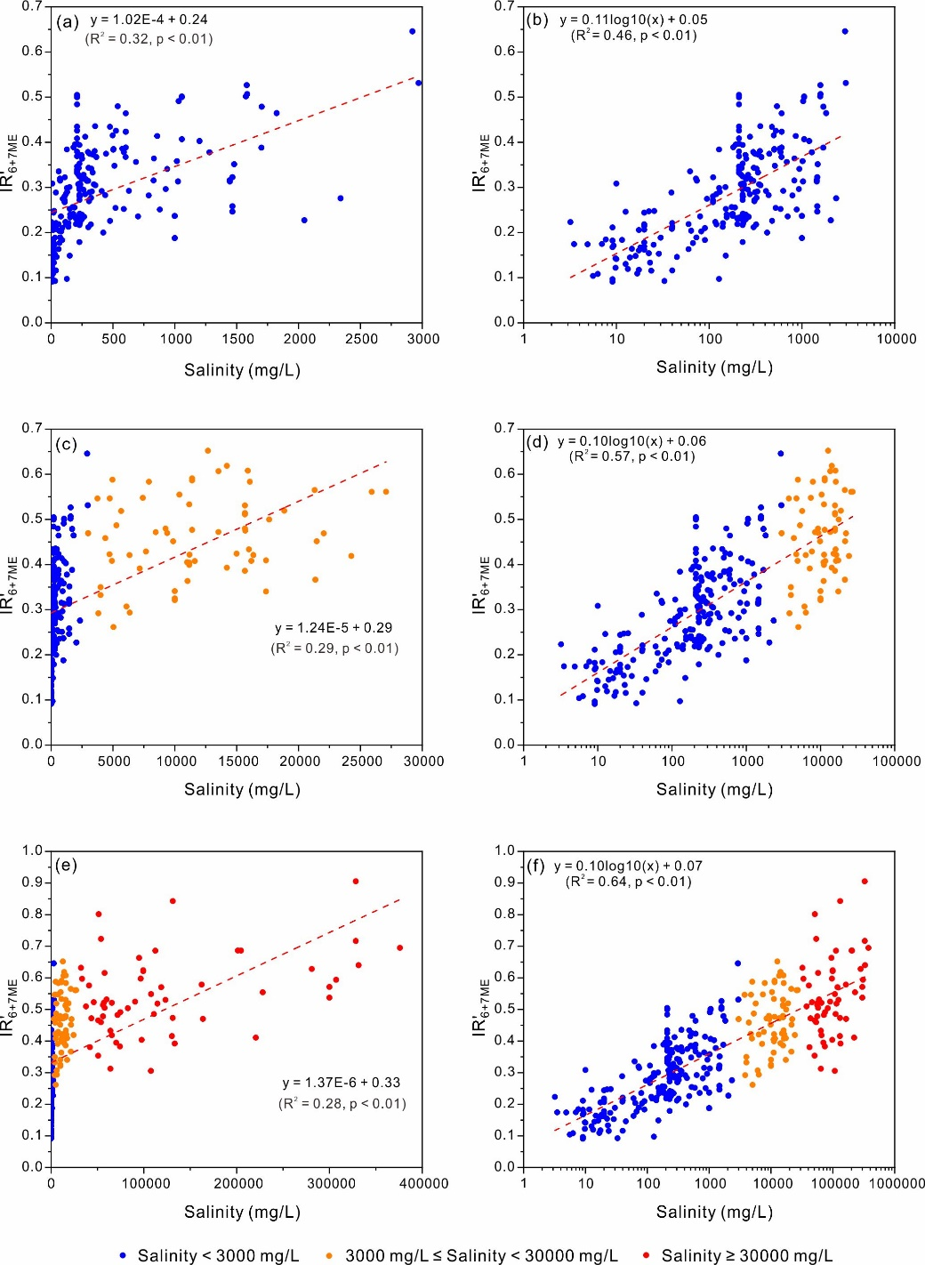Fig. S3. Correlation between IR'6+7ME index and salinity in different salinity ranges under linear (a, c, and e) and logarithmic scale (b, d, and f) of salinity.